James McKenna

18000717

Aframe Project – User Guide

Contents

About Tree Runner 2

Setting up the Game 2

Playing the Game 3

Sources 4

Figure - Tree Runner Game

# About Tree Runner

Tree Runner is a game designed to be run on a website, which can be ran locally using a remote server, such as Servez or Uniform Server. Also, Tree Runner has been developed using HTML (HyperText Markup Language), JavaScript and A-Frame; this language is used to create VR (Virtual Reality) frameworks on the web. The purpose of Tree Runner is to avoid as many trees as possible using the necessary device, currently playable on PC, android and iPhone; many endless runner games have been popular in the gaming community, especially among mobile devices. Furthermore, in Tree Runner, there are three lanes that the user can be in at one time, where endless trees will block the user’s path, requiring the user to navigate across the forest. For every tree the user passes, they gain one point, which is shown in the middle of the screen when they start the game.

# Setting up the Game

To start up the game, the user must host a server locally. Using the local server host, navigate to the file directory where the game is saved, from there, click start and three local servers will now be available. From there, go onto any installed web browser and type [***http://localhost:8080***](http://localhost:8080) into the search bar; this will now boot up the game. For VR mode on mobile devices, check the ***Use HTTPS*** icon before hosting the local server, then type [***https://192.168.0.112:8080***](https://192.168.0.112:8080) into the search bar.

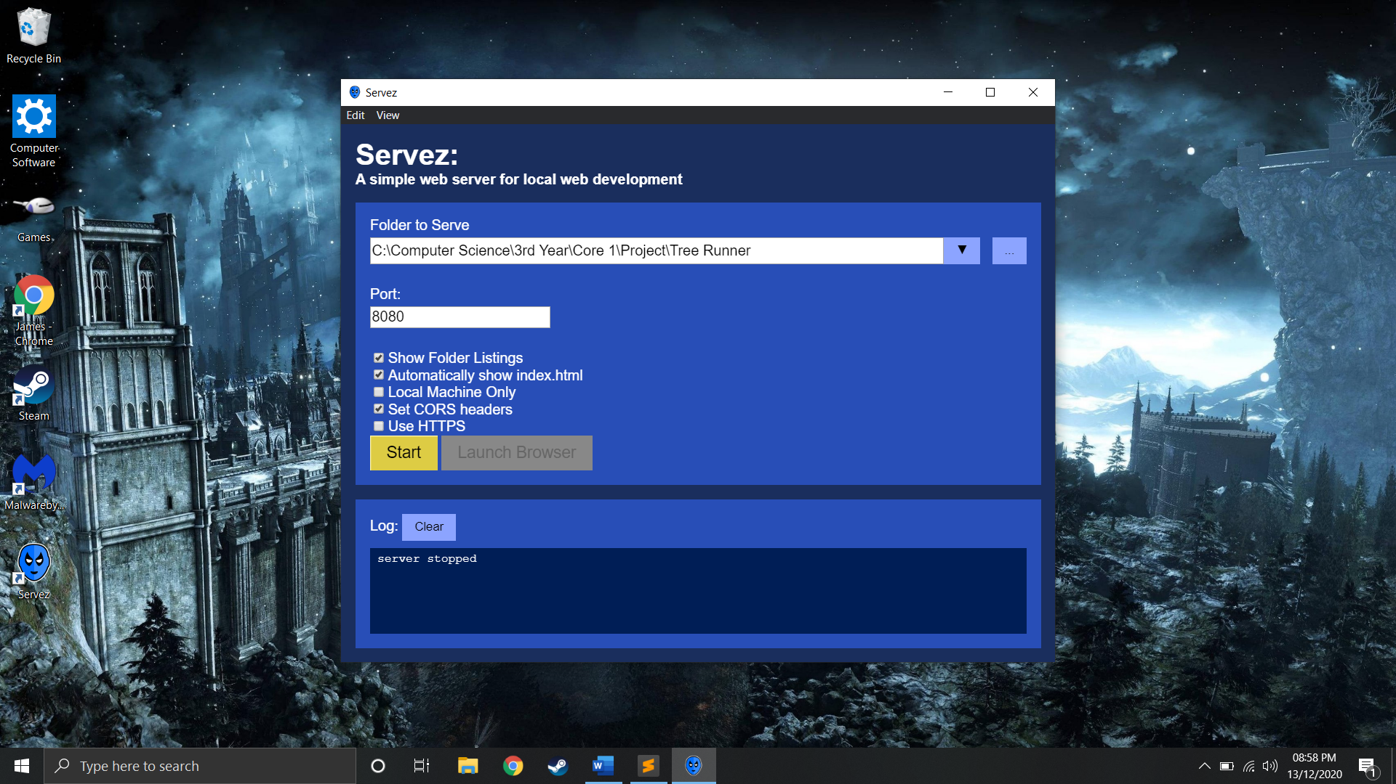

Figure - Hosting a Local Server

# Playing the Game

Once the user has successfully booted up the game on their web browser, the game can now be played. On PC, hold the left click of the mouse to turn left and right and look at the ***Start*** button using the centre pointer to start the game. Once the game has started, a counter will be displayed on the screen, where the user must avoid the trees to score points. Also, the background is a full 360o image, so the user can look at the background from all angles, providing an excellent background for Virtual Reality.

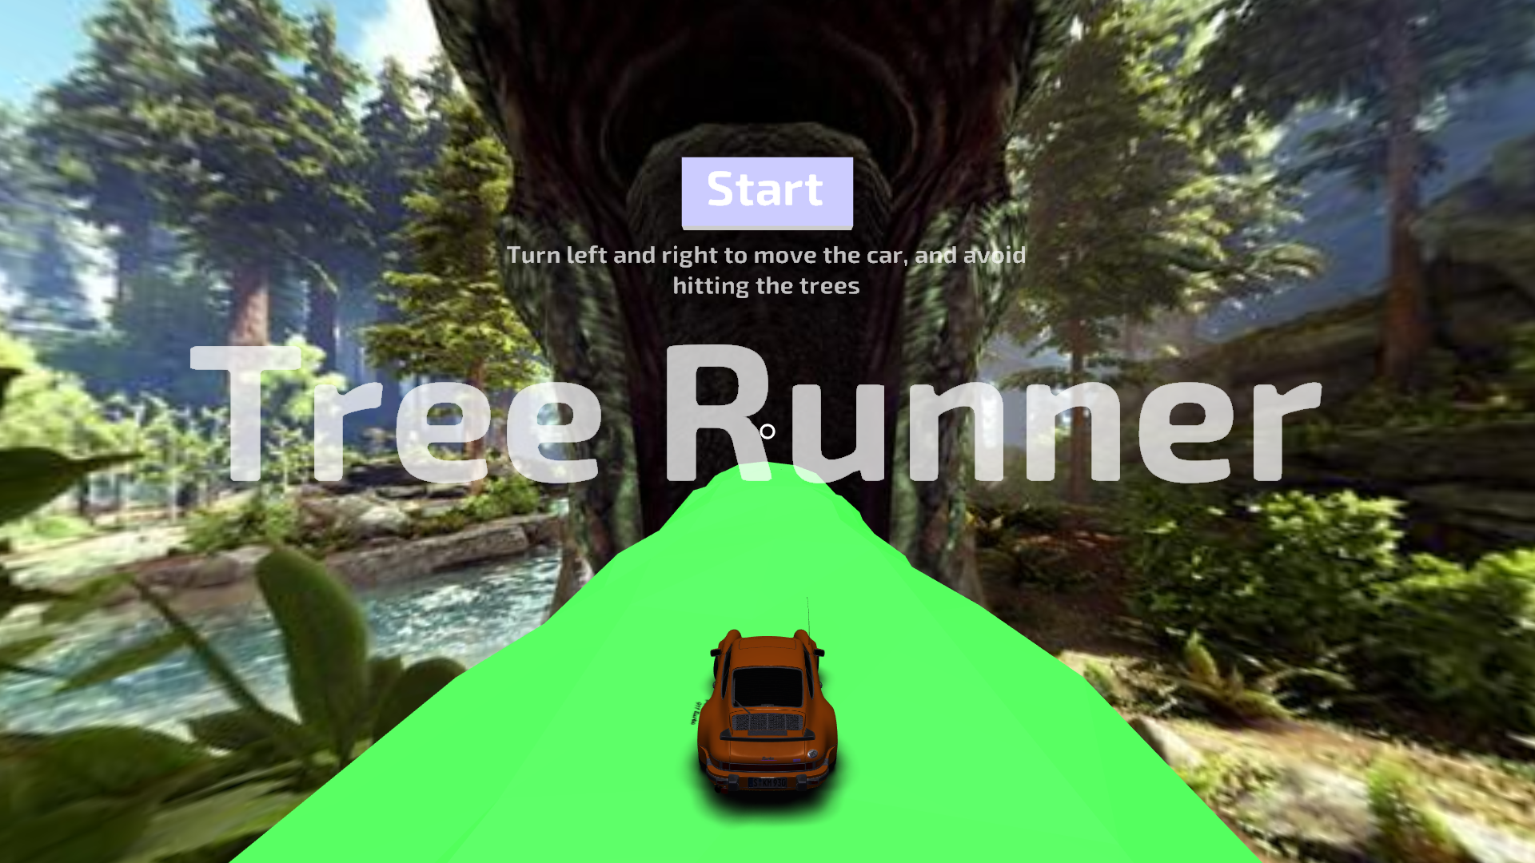

Figure - Main Menu of Tree Runner

Moreover, if the user is hit by a tree during the game, the game is over, and the score is displayed. From there, the user may restart the game to try and beat their score.

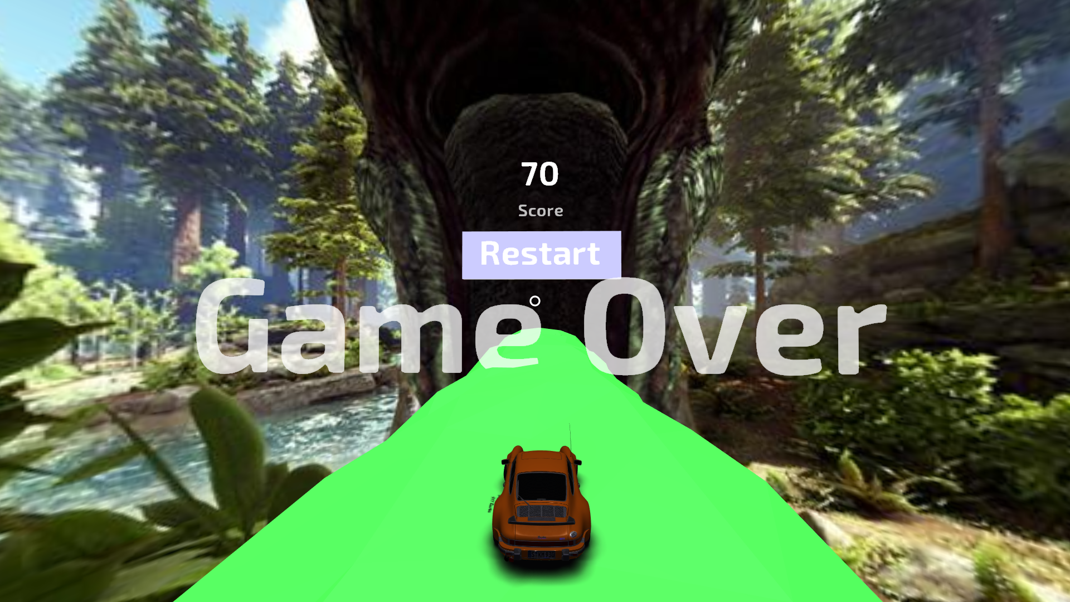

Figure - What happens when you lose

# Sources

Furthermore, the assets used in this project have been sourced by other content creators. The background was captured by Johnathan Wendel, whose online alias is FataL1ty; the image was created using NVIDIA Ansel in the video game ARK: Survival Evolved. Also, the vehicle the player controls was created by Karol Miklas, who uploaded their model on Sketchfab - the 3D model is free to download. Finally, the background music used when the user starts the game is called The Overseer, composed by Gareth Coker for the video game ARK: Survival Evolved.